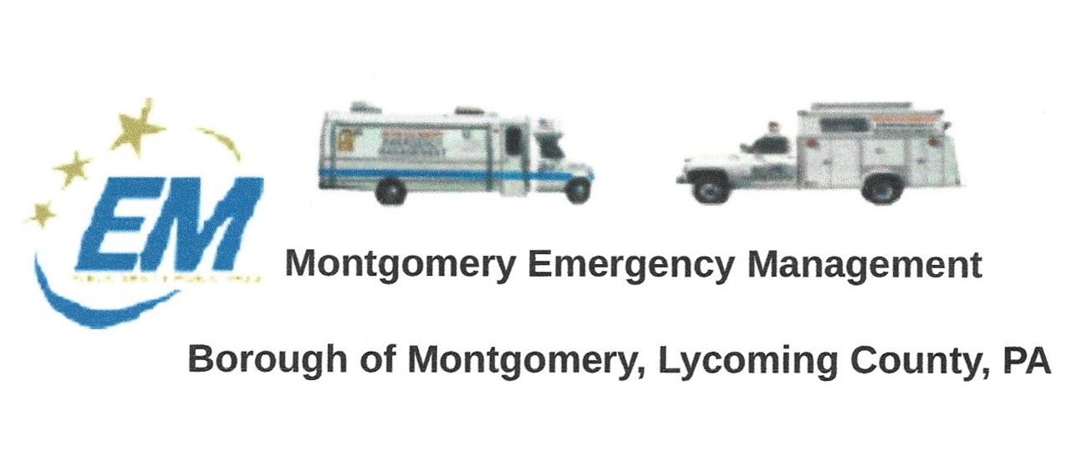

Greg Gruver, EMA Coordinator. 77 East Houston Avenue, Montgomery, PA 17752
Telephone: 570-547-1212. Cell: 570-419-4866. Email: montema631@gmail.com
Fae Herb, Administrative Assistant. 102 Broad Street, Montgomery, PA 17752
Cell: 570-506-9892. Email: faeherb@aol.com
Meeting Room and Equipment Building: 40 Thomas Avenue
Borough EOC: 570-547-1671 Fire Hall EOC: 570-547-1380
INTERNET WEBSITE: WWW.montgomeryboroughema.org

The regular monthly meeting of the Montgomery Borough Emergency Agency will be:
Thursday, November 10, 2022. 7 p.m.
Notes from Fae Herb – Administrative Assistant
November brings us colder weather. We appreciate EMA members maintaining the equipment, and preparing for winter.
MAMA (Muncy Area Mutual Aid) was scheduled for October 22nd & 23rd, several local fire companies participated with classes being held for training purposes. The Montgomery EMA is an honorary member and Dennis Gruver distributed water to the various companies participating.
We would like to thank the Montgomery Borough for their continuing support to the EMA and for their donation that will go towards the purchase of a used pick-up truck to replace the 1994 Chevrolet pickup. We are also sending out letters for donations from various businesses. Members looking for a respectable used pickup and appreciate everyone’s help in this search.
Members help assist the Lions Club with the annual Halloween parade. Supplying light sources to disembark from the floats, as well as radio contact during the parade progress. Members will also be assisting with the distribution of food and gift boxes at Christmas time. We expect more families needing assistance this year due to the rising costs.
If you are interested in becoming a member of the Montgomery EMA, please attend our next monthly meeting on Thursday, November 10th at 7 p.m. Meetings are held in the meeting room (trailer behind the EMA garage) on Thomas Avenue.

Refreshments for November will be provided by Greg Gruver
Remember Radio check every Tuesday at 6 p.m.

